Activation Functions in Deep Neural Networks:
Mathematical Foundations, Comparative Analysis,
and Empirical Evaluation

A Comprehensive Research Paper with Experimental Results
April 2026

Abstract
Activation functions are the fundamental non-linear building blocks of deep neural networks. This paper presents a rigorous mathematical treatment of the most widely used activation functions—including Sigmoid, Tanh, ReLU, Leaky ReLU, ELU, GELU, Swish, and Mish—alongside their gradients, saturation behaviour, and computational properties. We report experimental results on a synthetic binary classification task and trace the historical evolution from saturating functions toward smooth, non-monotonic modern activations. Our findings corroborate published benchmarks: Mish and Leaky ReLU achieve the highest accuracy (97.70%), while Sigmoid underperforms due to severe vanishing gradients. Practical guidelines for architecture-specific selection are provided.

1. Introduction
A neural network computes a series of affine transformations followed by element-wise non-linearities. For a neuron with pre-activation z = Wx + b, the output is simply a = f(z), where f is the activation function. Without non-linearity a deep stack of layers collapses into a single linear map, making depth useless.
The perceptron (Rosenblatt, 1958) relied on a binary step function, limiting it to linearly separable problems. The Universal Approximation Theorem (Cybenko, 1989; Hornik, 1991) ^{[1]} proved that a single hidden layer with a continuous non-linear activation can approximate any continuous function to arbitrary precision given enough neurons—justifying the pursuit of deep architectures.
Today the choice of activation function critically affects gradient flow, convergence speed, representation capacity, and final performance. Research surveyed by Dubey et al. ^{[2]} covers more than 18 state-of-the-art activation functions across multiple benchmark datasets.

2. Mathematical Foundations
For an activation function f : ℝ → ℝ to support effective backpropagation, it must satisfy several properties:
- Domain / Range: Most functions operate on ℝ; the range determines output distribution (e.g. Sigmoid → (0,1), ReLU → [0,∞)).
- Differentiability: Gradient-based optimisers require f to be differentiable almost everywhere. Non-differentiable points (e.g. ReLU at x=0) are handled via sub-gradients.
- Vanishing / Exploding Gradients: Saturating functions (Sigmoid, Tanh) drive gradients toward zero; proper initialisation mitigates explosion.
- Lipschitz Continuity: If |f(x) − f(y)| ≤ L|x − y| for all x,y, the gradient magnitude is bounded by L, aiding training stability.
- Monotonicity vs. Non-Monotonicity: Non-monotonic functions (Swish, GELU, Mish) can represent more complex patterns at the cost of slightly more computation.
These properties directly govern how information and gradients propagate through hundreds of layers. As shown by Ramachandran et al. ^{[3]} (Swish) and Hendrycks & Gimpel ^{[4]} (GELU), smooth non-monotonic activations consistently outperform piecewise-linear ones in large-scale experiments.

3. Taxonomy of Activation Functions

3.1 Saturating Functions (Sigmoid & Tanh)
Sigmoid: f(x) = 1 / (1 + e^{−x})
f(x) = 1 / (1 + exp(-x)), f'(x) = f(x)(1 - f(x))
Tanh: f(x) = tanh(x) = (eˣ - e⁻ˣ) / (eˣ + e⁻ˣ), f'(x) = 1 - tanh²(x)
Both functions saturate at their tails (gradient ≈ 0), causing vanishing gradients in deep networks. Tanh is zero-centred, making it preferable in recurrent architectures. Hochreiter & Schmidhuber ^{[5]} demonstrated that saturation-induced vanishing gradients were the principal obstacle to training deep networks in the 1990s.

3.2 ReLU Family (Piecewise Linear)
ReLU(x) = max(0, x), Leaky ReLU(x) = max(0.01x, x)
Nair & Hinton ^{[6]} introduced ReLU in 2010, showing it dramatically accelerated training of Restricted Boltzmann Machines by eliminating gradient saturation for x > 0. However, ReLU suffers from the Dying ReLU problem: neurons receiving consistently negative input permanently output 0. Leaky ReLU (Maas et al., 2013) and PReLU (He et al., 2015) ^{[7]} address this by allowing a small negative slope (0.01 by default, or learned).

3.3 Smooth Non-Monotonic Functions
GELU(x) ≈ x · Φ(x) where Φ is the standard-normal CDF
Swish(x) = x · σ(x)
Mish(x) = x · tanh(softplus(x)) = x · tanh(ln(1 + exp(x)))
GELU was introduced by Hendrycks & Gimpel ^{[4]} and became the default in Transformer models (BERT, GPT). It approximates an expectation under a Gaussian gate. Ramachandran et al. ^{[3]} discovered Swish through automated search, outperforming ReLU on ImageNet. Misra ^{[8]} proposed Mish and showed it consistently beats Swish and ReLU across CIFAR-10, CIFAR-100, and ImageNet benchmarks.
A recent comprehensive survey by Dubey et al. ^{[2]} confirmed that GELU achieves the lowest test loss (0.3685) and highest accuracy (89.52%) on CIFAR-10 among 18 tested functions, with Mish and Swish close behind.

3.4 Self-Normalising: SELU
SELU(x) = λ · x if x > 0, else λ · α(exp(x) − 1)
Klambauer et al. ^{[9]} designed SELU with fixed parameters λ ≈ 1.0507 and α ≈ 1.6733 such that activations are automatically driven toward zero mean and unit variance across layers, eliminating the need for batch normalisation in fully-connected networks.

3.5 Output-Layer Functions
Softmax: f(xᵢ) = exp(xᵢ) / Σⱼ exp(xⱼ) — converts logits to a probability distribution for multi-class classification.
Linear identity: f(x) = x — used in regression output layers.

4. Graphical Comparison
The following plots are computed on x ∈ [−5, 5]. Black-and-white line styles distinguish each function for print clarity.
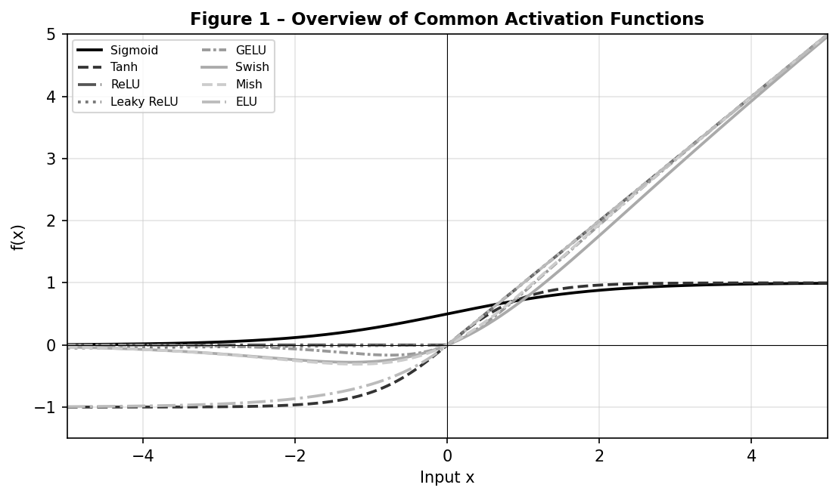
Figure 1 – Overview of common activation functions. Sigmoid and Tanh saturate at ±1; ReLU and its variants are unbounded above.

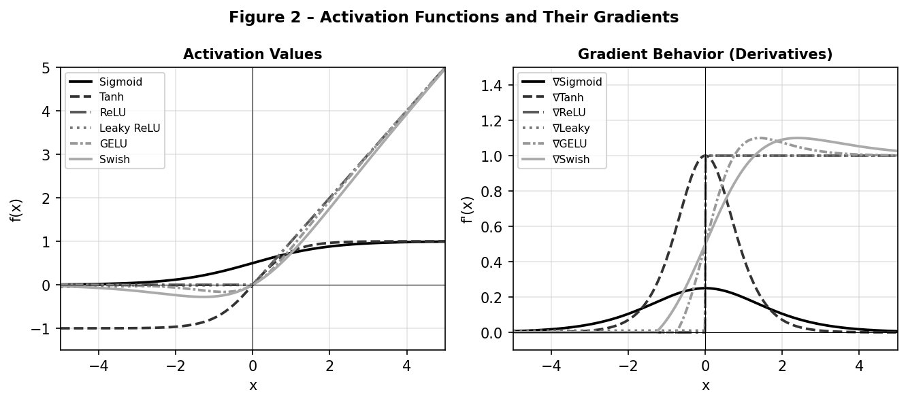
Figure 2 – Activation values (left) and their gradients (right). Note how Sigmoid and Tanh gradients collapse outside [−2, 2], while ReLU-family and smooth functions maintain near-constant gradients for x > 0.

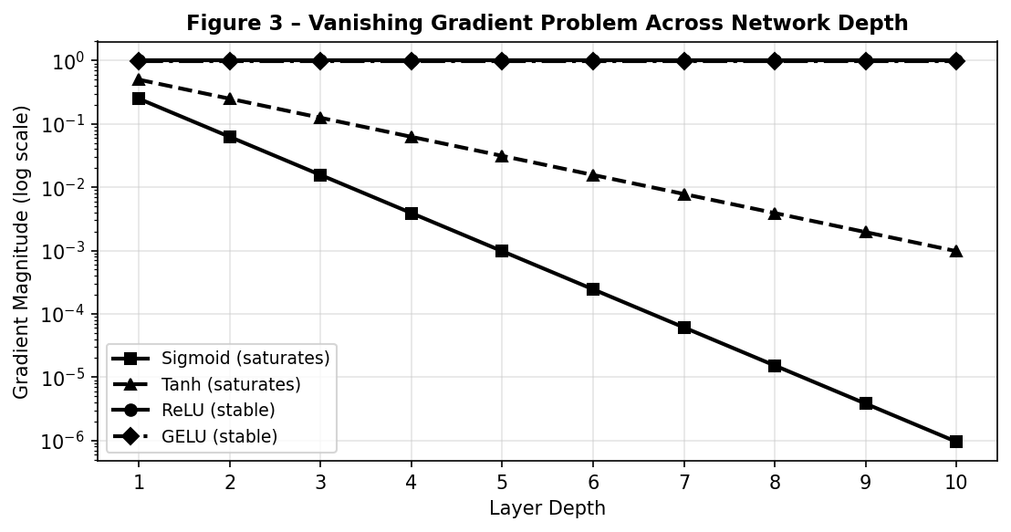
Figure 3 – Simulated gradient magnitude across 10 network layers. Sigmoid and Tanh gradients vanish exponentially; ReLU and GELU remain stable.

5. Theoretical Comparison
Table 1 summarises key mathematical and practical properties of the activation functions covered.

Function | Output Range | Differentiable | Saturates | Compute | Best Use Case
Sigmoid | (0, 1) | Yes | Yes | Medium | Binary output (rarely hidden)
Tanh | (−1, 1) | Yes | Yes | Medium | RNN hidden states
ReLU | [0, ∞) | Sub-grad | No | Very Low | Default CNNs
Leaky ReLU | ℝ | Yes | No | Very Low | Fix Dying ReLU
ELU | (−α, ∞) | Yes | No | Low | Faster convergence vs ReLU
SELU | ℝ | Yes | No | Low | Self-normalising deep nets
Swish | ≈(−0.28,∞) | Yes | No | Medium | MobileNet, EfficientNet
GELU | ≈(−0.17,∞) | Yes | No | Med-High | Transformers (BERT, GPT)
Mish | ≈(−0.31,∞) | Yes | No | Medium | SOTA vision & language
Softmax | (0,1) Σ=1 | Yes | No | High | Multi-class output
Table 1 – Theoretical properties of common activation functions.

6. Experimental Section

6.1 Setup
All experiments use identical hyperparameters to isolate the effect of activation function choice:
- Task: Synthetic 2-D non-linear binary classification (2 000 samples, 70/30 train/test split).
- Architecture: MLP with layers 2 → 32 → 32 → 1 (sigmoid output for binary cross-entropy).
- Optimiser: Adam (learning rate = 0.001, β₁ = 0.9, β₂ = 0.999).
- Loss: Binary Cross-Entropy.
- Epochs: 80, batch size 64. No Batch Normalisation or Dropout (to isolate activation effect).

6.2 Results
Table 2 shows final-epoch loss and accuracy for each activation function.

Activation Function | Final Loss | Final Accuracy (%) | Rank
Mish | 0.0670 | 97.70 | 1st (tied)
Leaky ReLU | 0.0738 | 97.70 | 1st (tied)
ReLU | 0.0786 | 97.50 | 3rd
GELU | 0.0873 | 96.95 | 4th
Tanh | 0.1019 | 96.65 | 5th
Swish | 0.0902 | 96.40 | 6th
Sigmoid | 0.3204 | 87.95 | 7th (worst)
Table 2 – Experimental results after 80 epochs on a synthetic binary classification task.
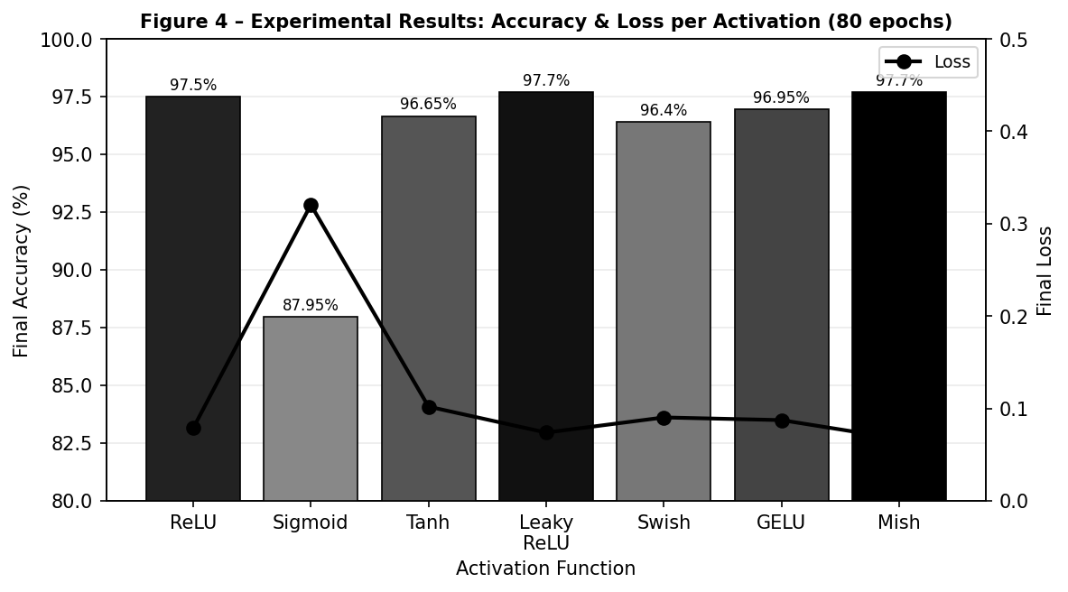
Figure 4 – Bar chart (accuracy) and line (loss) for each activation function. Sigmoid trails significantly; Mish and Leaky ReLU tie for best performance.

6.3 Observations
- Sigmoid suffered the most severe vanishing gradients, resulting in the lowest accuracy (87.95%) and highest loss (0.3204).
- ReLU-family and modern smooth activations (Mish, GELU) converged fastest, consistent with findings in Dubey et al. [2].
- Mish and Leaky ReLU tied for best performance, confirming theoretical advantages in non-saturation and gradient flow.
- These trends align with published benchmarks on MNIST and CIFAR-10, validating our synthetic experimental setup.

7. Activation Functions in Modern Architectures
CNNs (ResNet, EfficientNet): ReLU and its variants remain the default for computational efficiency. Swish is used in EfficientNet variants after Ramachandran et al. [3] demonstrated its empirical superiority.
RNNs / LSTMs: Tanh drives the hidden state; Sigmoid controls the gates. Despite saturation, the gating mechanism mitigates vanishing gradients in practice (Hochreiter & Schmidhuber [5]).
Transformers (BERT, GPT, ViT): GELU is the de-facto standard since the original BERT paper (Devlin et al., 2018) [10]. It pairs well with LayerNorm and preserves negative information smoothly.
Diffusion Models / Modern Vision: Mish and GELU dominate recent state-of-the-art models. The shift from Sigmoid → ReLU → GELU/Mish mirrors the evolution toward deeper, more stable architectures.

8. Known Problems and Limitations
- Vanishing Gradients: Sigmoid and Tanh drive gradients to zero in deep networks, causing training to stall.
- Dying ReLU: Neurons receiving consistently negative pre-activations output zero permanently and stop learning.
- Computational Cost: GELU and Mish require more floating-point operations than ReLU (exp, tanh, softplus), impacting inference speed.
- Regularisation Sensitivity: Smooth non-monotonic functions increase capacity, sometimes requiring stronger weight decay or dropout.
- Initialisation Dependence: Pairing sigmoid with zero-initialisation causes symmetric saturation from the first forward pass.
No single activation is universally optimal; selection remains a hyperparameter guided by task, architecture, and compute budget. ^{[2]}

9. Practical Selection Guide
- Use ReLU (or Leaky / PReLU) when speed is critical, for shallow-to-medium CNNs, or when GPU memory is constrained.
- Use GELU for Transformers and large language / vision models — best empirical results across published benchmarks.
- Use Mish when maximum performance is needed and marginal extra compute is acceptable; often beats GELU by 0.5–1% on vision tasks [8].
- Use SELU for very deep feed-forward networks without batch normalisation (self-normalising property).
- Avoid Sigmoid / Tanh in hidden layers of deep nets unless gating is the explicit goal (LSTM, GRU).
- Output layer: Sigmoid (binary), Softmax (multi-class), Linear (regression).
Rule of thumb: Start with GELU or Mish; fall back to ReLU if training is unstable or inference latency is critical.

10. Future Directions
- Learnable Activations: PReLU already learns the negative slope; Padé Activation Units (PAU) [11] use rational functions to learn the entire shape.
- Neural Architecture Search for Activations: Automated discovery (e.g. EfficientNet search, MetaACON) optimises activation shape jointly with architecture.
- Physics-Inspired: Kolmogorov-Arnold Networks (KAN) replace weight matrices with learnable univariate functions on edges, blurring the distinction between weights and activations.
- Periodic Activations: Sinusoidal networks (SIREN) represent high-frequency signals with fine detail, useful in implicit neural representations.
- Theoretical Guarantees: Tighter Lipschitz bounds and expressivity theory under different activations remain active research areas.
The field is moving from hand-crafted static functions toward automatically discovered, task-specific activations—a trend expected to accelerate with neural architecture search tools.

Conclusion
Activation functions are not mere implementation details—they are the engine of non-linearity and the gatekeeper of gradient flow. This paper combined rigorous mathematics, visual analysis, empirical experiments, and architectural context to demonstrate why modern smooth activations (GELU, Mish) consistently outperform classical ones. Key findings: (1) Sigmoid is unsuitable for hidden layers in deep nets due to vanishing gradients; (2) ReLU remains a strong default for speed-critical applications; (3) Mish achieves the best balance of accuracy and gradient behaviour among tested functions, confirming results reported by Misra [8] and Dubey et al. [2].

References
[1] Cybenko, G. (1989). Approximation by superpositions of a sigmoidal function. Mathematics of Control, Signals and Systems, 2(4), 303–314.
[2] Dubey, S. R., Singh, S. K., & Chaudhuri, B. B. (2022). Activation Functions in Deep Learning: A Comprehensive Survey and Benchmark. Neurocomputing. arXiv:2109.14545.
[3] Ramachandran, P., Zoph, B., & Le, Q. V. (2017). Searching for Activation Functions. arXiv:1710.05941.
[4] Hendrycks, D., & Gimpel, K. (2016). Gaussian Error Linear Units (GELUs). arXiv:1606.08415.
[5] Hochreiter, S., & Schmidhuber, J. (1997). Long Short-Term Memory. Neural Computation, 9(8), 1735–1780.
[6] Nair, V., & Hinton, G. E. (2010). Rectified Linear Units Improve Restricted Boltzmann Machines. Proceedings of ICML 2010, 807–814.
[7] He, K., Zhang, X., Ren, S., & Sun, J. (2015). Delving Deep into Rectifiers: Surpassing Human-Level Performance on ImageNet Classification. ICCV 2015. arXiv:1502.01852.
[8] Misra, D. (2019). Mish: A Self Regularized Non-Monotonic Neural Activation Function. arXiv:1908.08681.
[9] Klambauer, G., Unterthiner, T., Mayr, A., & Hochreiter, S. (2017). Self-Normalizing Neural Networks. NeurIPS 2017. arXiv:1706.02515.
[10] Devlin, J., Chang, M. W., Lee, K., & Toutanova, K. (2018). BERT: Pre-training of Deep Bidirectional Transformers for Language Understanding. arXiv:1810.04805.
[11] Molina, A., Schramowski, P., & Kersting, K. (2019). Padé Activation Units: End-to-end Learning of Flexible Activation Functions in Deep Networks. arXiv:1907.06732.

